TOWN

Of

**Milltown**

Polk County, Wisconsin

**ORDINANCE No. 2021-1 DESIGNATING CERTAIN TOWN ROADS**

**IN THE TOWN OF Milltown AS "CLASS B" HIGHWAYS**

The Town Board of the Town of **MILLTOWN, POLK** County, Wisconsin, has the specific authority under s 349.15 (2) , Wis. stats., to adopt this ordinance numbered **2021-1.**

SECTION I. - GENERAL PURPOSE

The purpose of this ordinance is to ensure the safety of the individuals living within the town and those individuals who use the town roads, by preventing frequent travel oflarge vehicles on the town roads other than for regular delivery within the town.

SECTION II. - ADOPTION OF STATE STATUTE

Chapters 348 and 349 Wisconsin Statute 2020-21, and any amendments thereto including words and definition; enforcement provisions, and penalties, are hereby adopted.

SECTION III. - AUTHORITY

The Town Board of the Town of Milltown has specific statutory authority under Wis. Stats.

349.15 to impose weight limitations on highways within its jurisdiction to protect the constructional integrity and the safety of those individuals using the town roads.

SECTION IV. -DESIGNATION OF ROADS

The following town highways in the Town of **MILLTOWN** are designated class "B" highways subject to the weight limits set forth in s. I' 1 1, Wis. stats., [no person, without a permit therefor, shall operate on a class "B" highway any vehicle or combination of vehicles imposing wheel, axle, group of axles, or gross weight on the highway exceeding 60 percent of the weights authorized in

s. 348.15 (3)] unless increased by town ordinance:

l. 120th St from 190th Ave to Termie

1. 190th Avenue from 120th St to State Highway 35
2. 200th Ave from Termie to State Highway 35
3. 170th Street South from 190th Ave to 240th Ave Not Including Village Limits
4. 140th Street South from 190th Ave to 200th Ave
5. 140th Street from County Road G to 220th Ave
6. Kemoh Park Drive from 180th Ave to 138th St
7. 138th Street from Kemoh Park Drive to 185th Ave
8. 195th Ave from 155th St to 160th St
9. 160th St from 195th Ave to 200th Ave
10. 150th St from State Highway 46 to 230th Ave
11. 185th Ave from 138th to 145th Street
12. 220th Ave from State Highway 46 to GG

The town chairperson, or his or her designee, shall place appropriate traffic signs on the above-

described highways on or before the effective date of **September 1, 2021,** for this ordinance.

SECTION V. - PENALTY PROVISIONS

No person may operate any vehicle on the above-noted highways in violation of the weight limits set forth in s.348.116 (2), Wis. stats. Upon conviction for a violation of this ordinance, the violator shall pay a forfeiture penalty, pursuant to Wisconsin Statute plus the applicable surcharges, assessments, and costs for each violation. Each trip in violation of this ordinance constitutes a separate offense. In addition, the town board may seek injunctive relief from a court of record to enjoin further violations.

SECTION VI. -ENFORCEMENT

In addition to those police and traffic officers designated in Section 349.02 Wis. Stat. 2020-21, the Town Board may by resolution designate such other person or persons to enforce this ordinance.

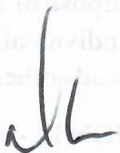

***J***

Adopted this 12th.day of July 2021.

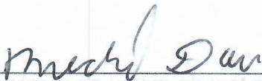

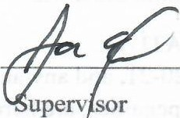**Attest:**

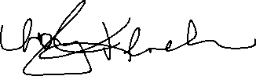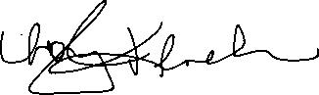

Town Chair

Town Clerk

Supervisor