Town of Milltown

Clerk, Poo. Box 475, Milltown, WI 54858

November 18, 2024, 7:05 pm at the Milltown Town Hall

Agenda for Budget Hearing and Special Town Meeting of Electorates

l) Call the Budget Hearing to order

* 1. Discussion on revenue and expenditure
  2. Discussion on levy — Town of Milltown tax levy will increase 40.62% for 2024, collected in 2025.

Il) Close the Budget Hearing

J. Gary Lilyquist made a motion to close the November 18, 2024 Budget Hearing, Jon Eckel seconded. Passed.

Ill) Open the Special Town Meeting to the Electorates

Chris Nelson made a motion to open the Special Town Meeting to the Electorates, Jon Eckel seconded. Passed.

1. Discussion on revenue and expenditure
2. Resolution of Town Board to Propose Exceeding Levy Limit (Public Resolution 24-1) -Jon Eckel made motion to accept the Public Resolution 24-1, J. Gary Lilyquist seconded. Passed.
3. Resolution to exceed the levy limit (Public Resolution 24-2) —Jon Eckel made a motion to accept the Public Resolution 24-2, Chris Nelson seconded. Passed.
4. Resolution to Adopt the Town Tax Levy (Public Resolution 24-3) — Jon Eckel made a motion to accept the Public Resolution 24-3, Chris Nelson seconded. Passed.
5. Close the Special Town Meeting to the Electorates

Jon Eckel made a motion to close the Special Town Meeting to the Electorates, J. Gary Lilyquist seconded. Passed.

Jon Eckel made a motion to move to the Town of Milltown regular Board meeting, Chris Nelson seconded. Passed.

Special Town Meeting of Electors Notice

Town of Milltown, Polk County

Notice is hereby given that a special town meeting of the Town of Polk County, Wisconsin, will be held in the town at Milltown Town Hall, 1502 200th Ave. Milltown on the 18th day of November 2024. The Town elector meeting will be held immediately following the completion of the Public Hearing on the proposed 2024 Town budget which begins at 7:05 p.m. for the following purposes:

l . To consider the adoption of a resolution by the town meeting endorsing a town board resolution which proposes that the town levy exceed the state allowable levy limit under s. 66.0602 of Wis. Statutes, specifically a proposed tax levy which would exceed the allowable town tax levy for 2024 by 40.62% percent which would be a dollar increase of $300,000 (the amount for Debt Service and Interest).

2. To approve the 2024 total town tax levy to be collected in 2025 pursuant to s. 60.10(1 )(a) of Wis. Statutes. which would be $1,038,500 plus Milltown Fire Association assessment of $77,351.00.

Posted November 3rd, 2024 at:

Milltown Town Hall, 1502 200th Ave

Milltown Post Office, 71 Main St

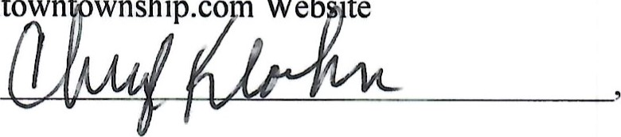Milltown wnship.co Web •te

By:Cheryl Kloehn

Town Clerk of the Town of Milltown

{Note that towns may either post this notice in 3 places (or one physical posting place and a town-maintained website) not more than 20 nor less than 15 days before the special town meeting publish this notice as a Class 2 notice in a qualified newspaper.}

Please note this sample Special Town Meeting ofElectors Notice is in addition to the Notice ofPublic Hearing and budget summary that must be posted in 3 places at least 15 days in advance ofthe public hearing, per s. 65.90(3)(a)1, Wis. Statutes.}

4

Public Budget Hearing and Special Town Meeting of Electors

Town of Milltown, Polk County

Notice is hereby given that on Monday, November 18th, 2024, at 7:05 p.m., at the Milltown Town Hall, 1502 200th Ave., Milltown, a public hearing on the proposed budget for 2025, will be held. The proposed budget in detail is available for review at the clerk's office by appointment call 715-566-0916. The following is a summary of the proposed 2025 Budget:

|  |  |  |  |  |  |  |  |  |
| --- | --- | --- | --- | --- | --- | --- | --- | --- |
|  |  | Jan - Sept 23 |  | Jan - Oct 18 |  |  | (Increase)  Decrease Budget | 2024 to  2025 |
|  | 2022 | 2023 | 2023 | 2024 | 2024 | 2025 | 2024 to | Percent |
| Revenue Accounts | Actual | Actual | Budget | Actual | Budget | Budget | 2025 | Change |

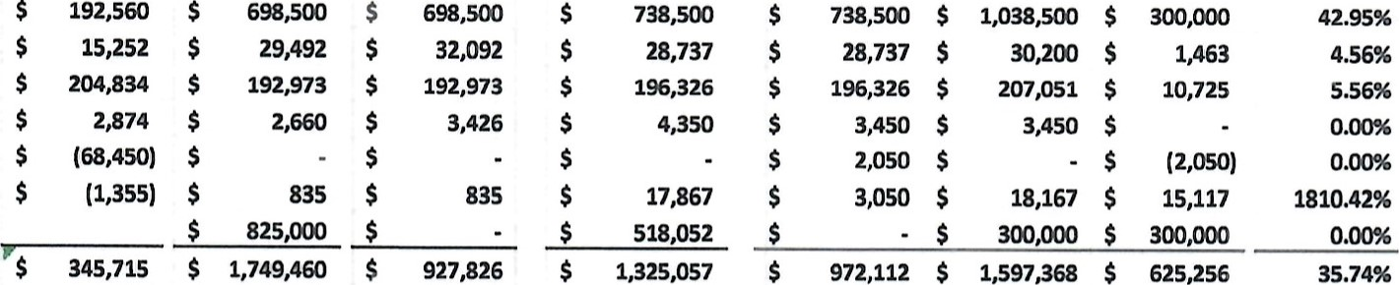Taxes (Levy)-41110

Taxes-40001-41150-41320

Intergovernmental Revenues-43000

Licenses & Permits-44000

Public Service Fees-46000

Miscellaneous Revenue-48000 Proceeds Long Term Debt-49000

TOTAL REVENUES

|  |  |  |  |  |  |  |  |  |
| --- | --- | --- | --- | --- | --- | --- | --- | --- |
|  |  | Jan - Sept 23 |  | Jan - Oct 18 |  |  | (Increase)  Decrease Budget | (Increase)  Decrease Budget |
|  | 2022 | 2023 | 2023 | 2024 | 2024 | 2025 | 2024 to | 2024 to |
| Expenditure Accounts | Actual | Actual | Budget | Actual | Budget | Buc%et | 2025 | 2025 |

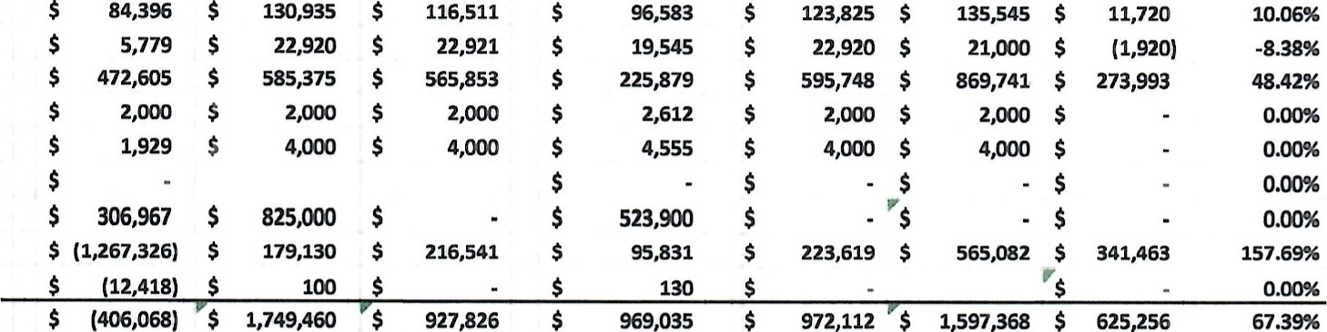General Govemment-51000

Public Safety-52000

Public Works-53000

Health & Human Services-54000

Culture, Recreation & Education-55000 Conservation & Development-56000 capital Outlay-57000 Debt Service Fund-58000 Other Financing Uses-59000 TOTAL EXPENDITURES

Special Town Meeting of Electors Notice Town of Milltown, Polk County

Notice is hereby given that a special town meeting of the Town of Polk County, Wisconsin, will be held in the town at Milltown Town Hall, 1502 200th Ave. Milltown on the 18th day  The Town elector meeting will be held immediately following the completion of the Public Hearing on the proposed 2025 Town budget which begins at 7:05 p.m. for the following purposes:

1. To consider the adoption of a resolution by the town meeting endorsing a town board resolution which proposes that the town levy exceed the state allowable levy limit under s. 66.0602 of Wis. Statutes, specifically a proposed tax levy which would exceed the allowable town tax levy for 2024 by 40.62% percent which would be a dollar increase of $300,000 (the amount for Debt Service and Interest).
2. To approve the 2024 total town tax levy to be collected in 2025 pursuant to s. 60.10( 1 )(a) of Wis. Statutes. which would be $1 plus Milltown Fire Association assessment of $77,351

Cheryl Kloehn, Clerk of the Town of Milltown

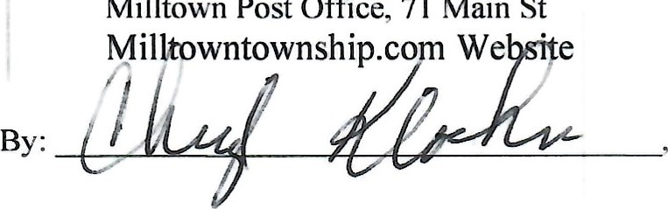

Posted:

Milltown

Town

Hall,

1502

200

th

Ave.

Milltown

Post

Office,

71

Main

St

COUNTY, WISCONSIN

Resolution of Town Board to Propose Exceeding Levy Limits

Resolution Number: 24-1

Whereas, the State of Wisconsin has adopted levy limits on town, village, city and county levies for 2018 and thereafter under

s. 66.0602 of Wis. Statutes;

Whereas, s. 66.0602 of Wis. Statutes limits the allowable local levy for 2024 to a percentage increase of no more than the greater of a percentage equal to the percent change in equalized value due to net new construction; which for the Town of Milltown is .635% percent;

Whereas, the Town Board of the Town of Milltown, Polk County believes that for the 2024 tax levy (collected in 2025) it is in the town's best interest to exceed the state levy limit as described above by a greater percentage than 0%.

Whereas, the Town of Milltown 2023 payable 2024 adjusted actual levy is $629,836; And further whereas the state law would limit the increase to dollar amount allowed for net new construction for an allowable town tax levy of $738,500 after adjustments, for 2024, collected in 2025.

Now Therefore the Town Board of the Town of Milltown, Polk County does hereby resolve and order as follows:

l . The town board supports an increase in the town tax levy for 2024 that will exceed the state levy limit.

2. The town board directs that the question of increasing the allowable town tax levy for 2024 (to be collected in 2025) by 40.62%, which would increase the allowable town levy by $ 300,000 (the amount for Debt Service and Interest) for a total town tax levy of $1,038,500 shall be placed on the agenda for the special town meeting to be held on November 1 8th ,2024.

Adopted this 18th day of November, 2024.

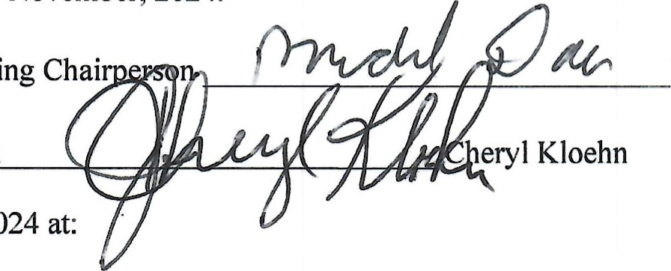Signature of Town Meeting Chai Michael Dau

Signature of Town Clerk

Posted November 3rd, 2024 at:

Milltown Town Hall, 1502 200th Ave

Milltown Post Office, 71 Main St

Milltowntownship.com Website

*Note that the starting point for this year's levy may not always be last year's actual levy. In some cases the starting levy for this year may be "adjusted" if there is a reduction due to a debt payment coming off the levy or a reduction for services transferred to other governmental units, etc.

**The town's allowable levy limit this year is further reduced by a Personal Property Aid payment due to a 201 g personal property tax law change. *** If your total town tax levy will include other adjustments (From Section D of the Levy Limit Worksheet) provide additional explanation of those adjustments here.****Note this resolution must be posted within 30 days of adoption by the town board, pursuant to s. 60.80 of Wis. Statutes. It also needs to be adopted by the town board at least 15 days prior to the special town elector meeting at which it will be voted on. This is because the special town elector meeting must be noticed at least 15 and not more than 20 days in advance pursuant to s. 60.12, Wis. Stat.

2

COUNTY, WISCONSIN

Resolution to Exceed the Levy Limit at Special Town Meeting of the Electors

Public Resolution Number: 24-2

Whereas, the State of Wisconsin has imposed levy limits under s. 66.0602 of the Wis. Statutes for town tax levies in 2021 and thereafter;

Whereas, s. 66.0602(5) of Wis. Statutes allows the town electors in towns under 3,000 in population to exceed the maximum allowable levy limit by adoption of a resolution at a town meeting of the electors;

Whereas, the town board has adopted a resolution supporting an increase in the town tax levy which would exceed the maximum allowable state levy limit for the Town of Milltown;

Whereas, this Special Town Meeting of the electors has been called and noticed to consider the adoption of a resolution to endorse the town board's resolution to exceed the state levy limits; specifically, by increasing the allowable town tax levy for 2024 (collected in 2025) by 40.62% percent;

Now, therefore, the special town meeting of the Town of Milltown, Polk County, Wisconsin, by a majority vote of the eligible electors voting on this 18th day of November, 2024 duly assembled and voting resolves and orders as follows:

BE IT HEREBY RESOLVED, that the town electors of the Town of Milltown, Polk County, Wisconsin endorse the town board resolution to increase the town tax levy for 2024 (collected in 2025) by 40.62% percent over the allowable 2024 levy, which is an increase of $300,000 (the amount for Debt Service and Interest) over the allowable 2024 town tax levy.

The town clerk shall properly post or publish this resolution as required by law under s. 60.80(1 of Wis. Statutes within 30 days of adoption.

Adopted this 18th day of November, 2024, at a Special Town Meeting.

Number of town electors voting aye

Number of town electors voting nay

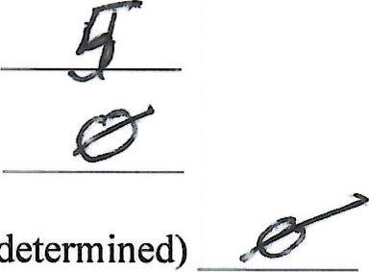Number abstaining or not voting (if determined)

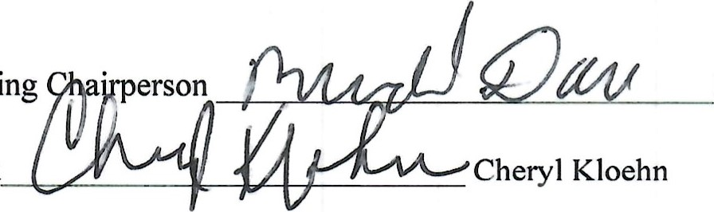Signature of Town Meeting Michael Dau

Signature of Town Clerk

Posted November 3rd, 2024 at:

Milltown Town Hall, 1502 200th Ave

Milltown Post Office, 71 Main St

Milltowntownship.com Website

By: 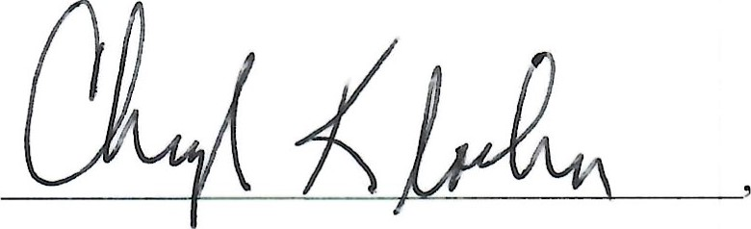 Cheryl Kloehn

Town Clerk of the Town of Milltown

COUNTY, WISCONSIN

Adopt the Town Tax Levy at Special Town Meeting of the Electors

Public Resolution Number: 24-3

Whereas, s. 60.10(l)(a) of Wis. Statutes authorizes the town electors of a town to adopt the town tax levy at a town meeting of the electors;

Whereas, a special town meeting of the electors has been called for this 18th day of November, 2024;

Whereas, the electors, after proper notice, have with a special town meeting vote, authorized the Town of Milltown to exceed the allowable state levy limit;

Now, therefore, the special town meeting of the Town of Milltown, Polk County, Wisconsin, by a majority vote of the eligible electors voting on this 18th day of November, 2024 duly assembled and voting resolves and orders as follows:

BE IT RESOLVED, the town electors of the Town of Milltown, Polk County, Wisconsin hereby adopt the town tax levy for 2024 to be collected in 2025 in the amount of $1,038,500.

The town clerk shall properly post or publish this resolution as required by law under s. 60.80(1 Wis. Statutes within 30 days of adoption.

Adopted this 18th day of November, 2()24, at a Special Town Meeting.

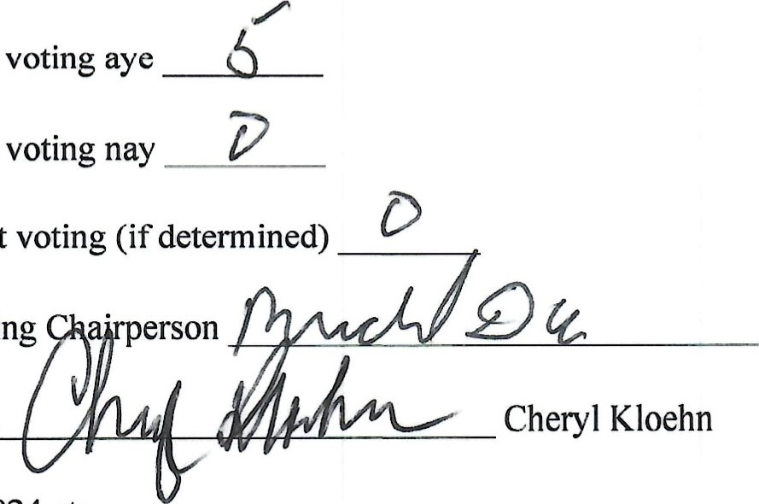Number of town electors voting aye

Number of town electors voting nay

Number abstaining or not voting (if determined)

Signature of Town Meeting Michael Dau

Signature of Town Clerk

Posted November 3rd, 2024 at:

Milltown Town Hall, 1502 200th Ave

Milltown Post Office, 71 Main St

Millto ship.com We site

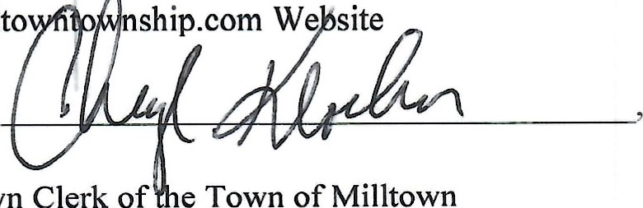

Town

Clerk

of

e

Town

of

Milltown

By: Cheryl Kloehn

*Note this resolution must be posted within 30 days of adoption by the town electors, pursuant to s. 60.80 of Wis. Statutes.

6