Sheet 1 of 1
STATE OF WISCONSIN
Town of Milltown
_Polk County

The Town Board of the Town of Milltown, Polk County, Wisconsin, hereby provides its written notice and an agenda of an Emergency Town Board Meeting of the Town Board for Thursday, February 16, 2023, at _7_p.m. at the Milltown Fire Hall, Milltown, Wisconsin. Communication of this emergency meeting has been provided to the requisite Town of Milltown Website, Town of Milltown Shop, Milltown Fire Hall and Milltown Post Office.

SPECIAL TOWN BOARD MEETING AGENDA

I. Call to order
- Town Shop Addition
- Summons
- Adjournment

Meeting notice posted this 15 day of February, 2023, on the Town's website at www.milltowntownship.com
and at:

Town of Milltown Shop 200th Ave and Hwy 46
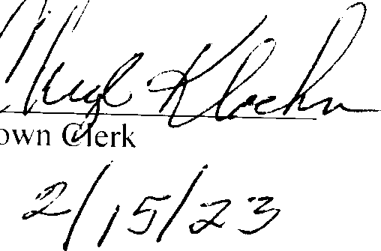
Milltown Fire Hall 129 Eiders St, Milltown, W 54858 Post Office Milltown Post Office

